The Veteran Car Club of Australia (Victoria) Inc.

Registration Number A0097964Y

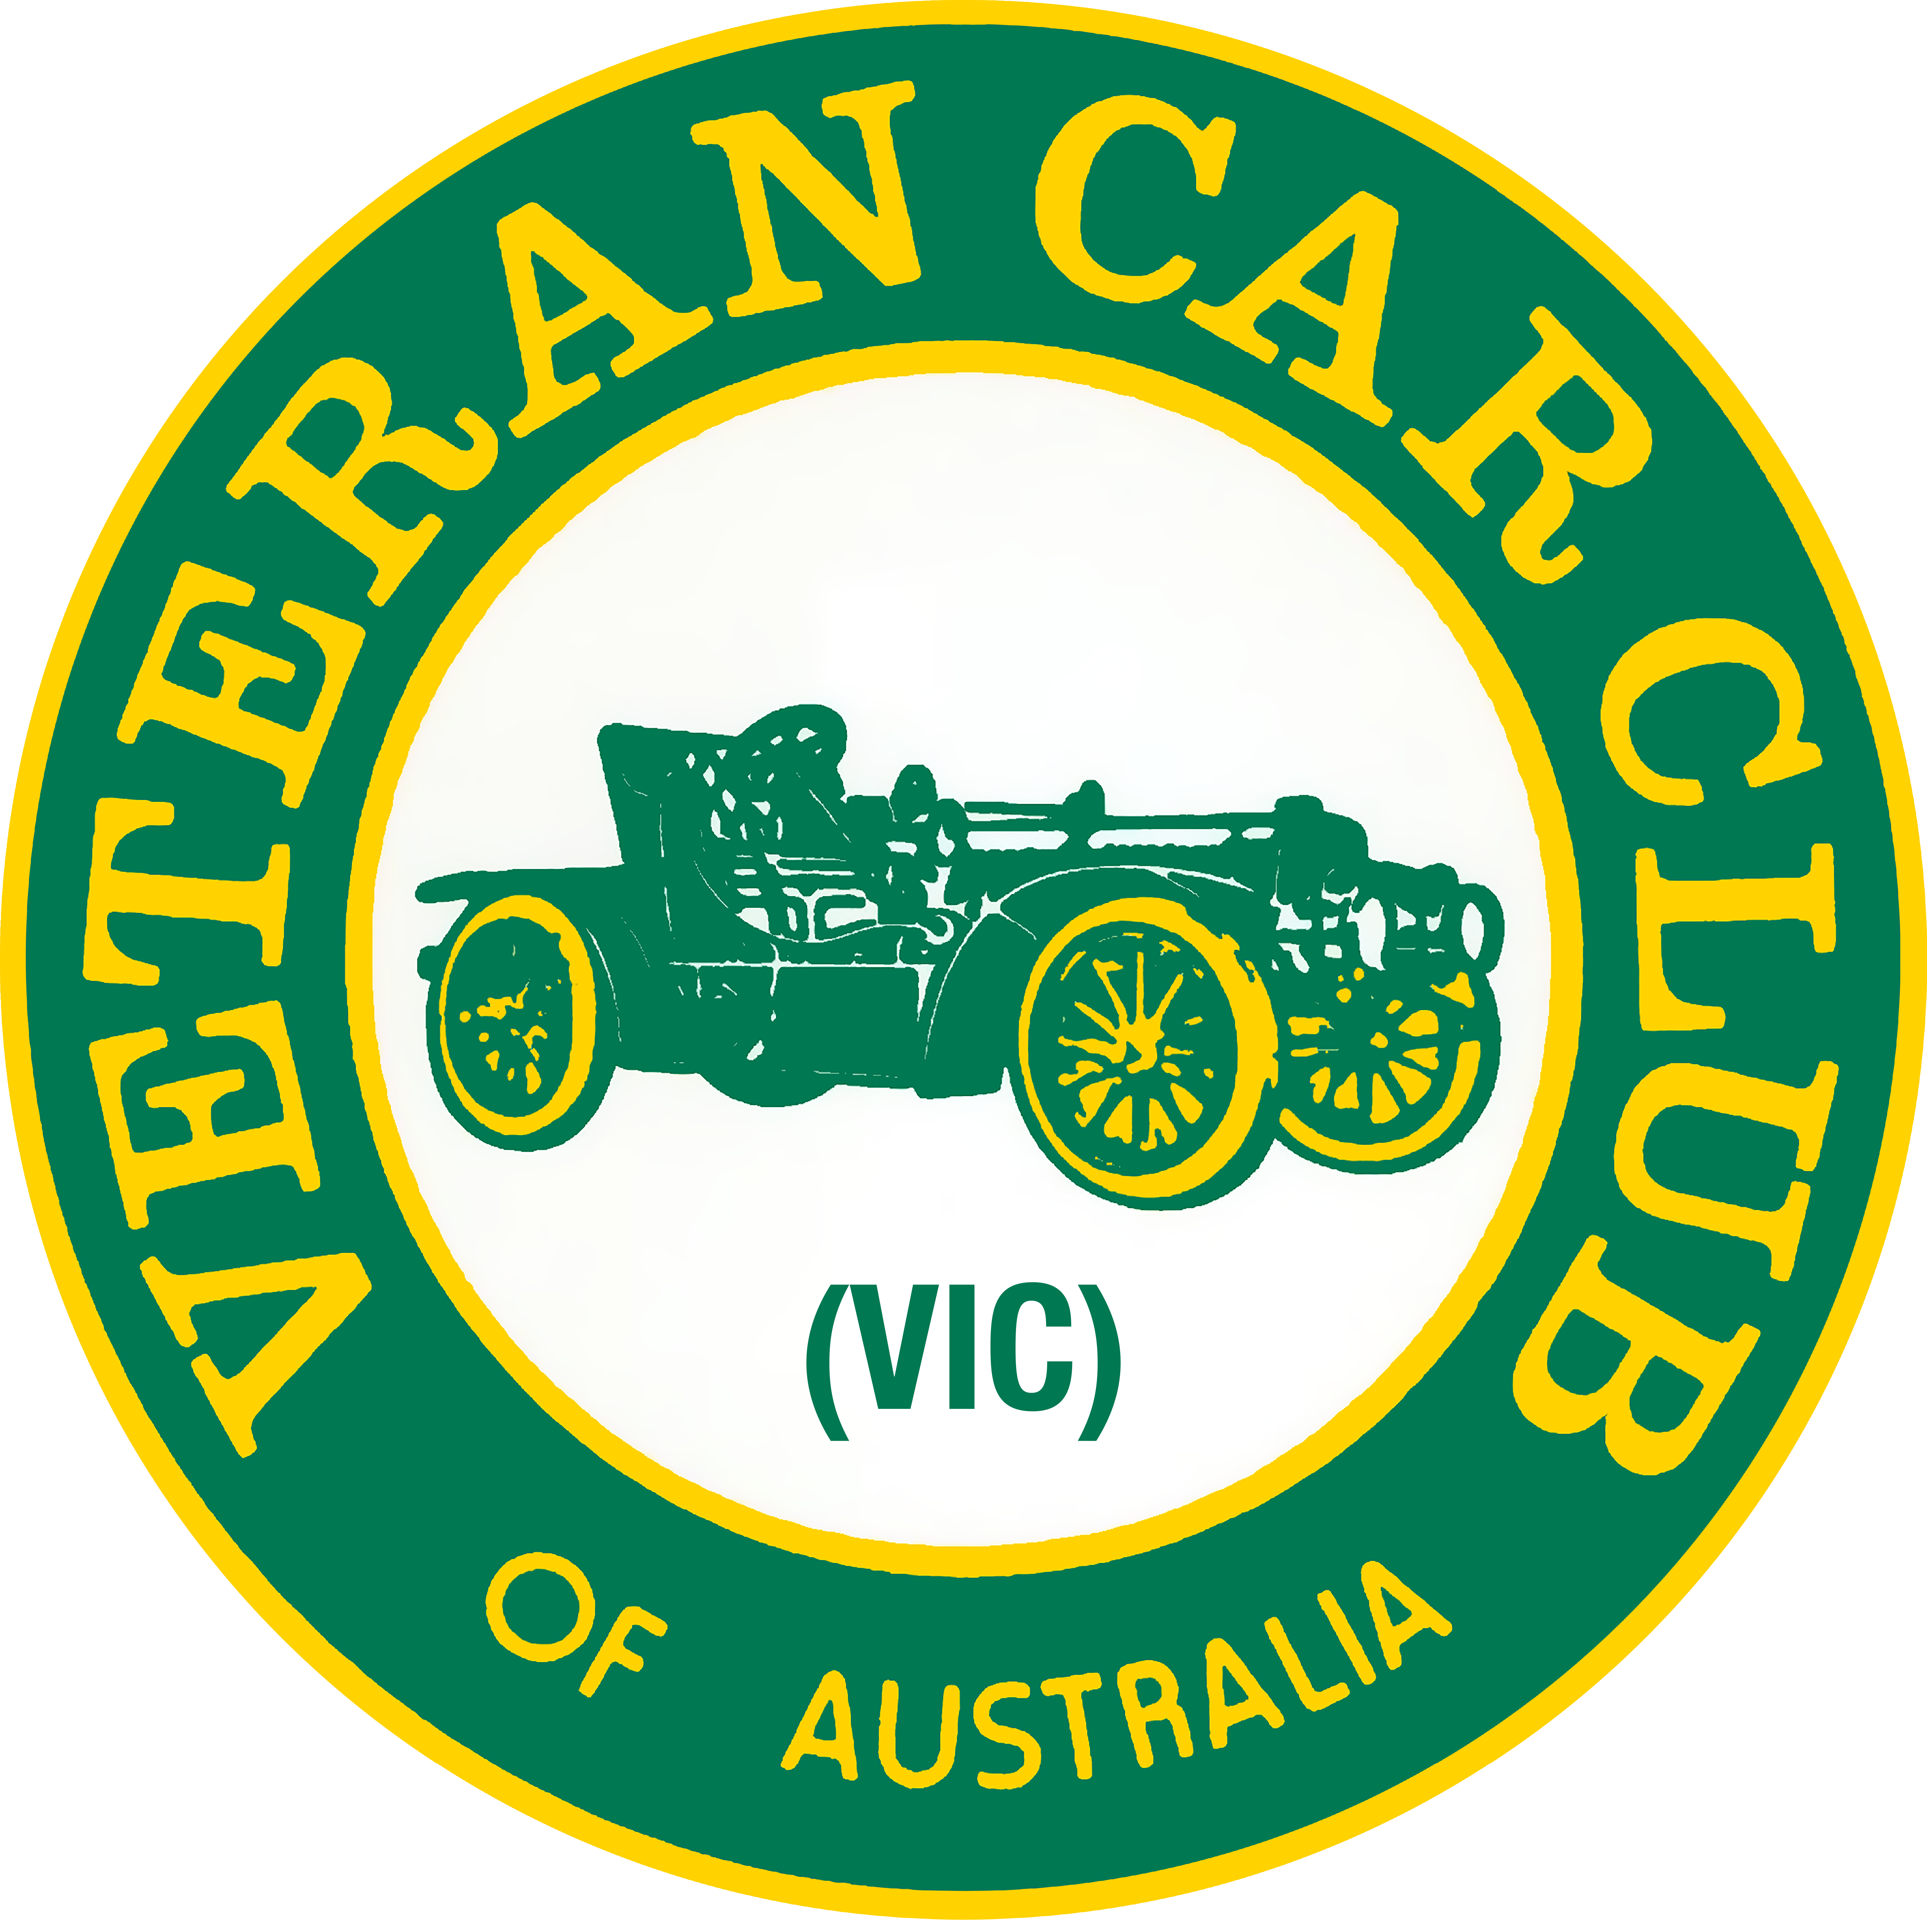
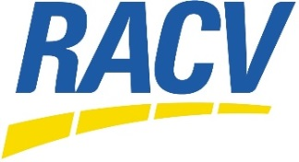
RACV

1&2 CYLINDER RALLY

COBRAM

Thursday 15 – Sunday 18 March 2018
Entries close Friday 16 February, 2018
Entry Form

CONTACT INFORMATION & ENTRY FORMS TO THE RALLY DIRECTORS

Andrew & Frances McDougall, 424 Wellington St, Clifton Hill, Victoria. 3068

Email: amfi@dunollie.com.au Ph: 03 94864221 Mob: 0427220249 (Andrew) 0417310852 (Frances)
ACCOMMODATION: All accommodation is at the RACV Resort & will be booked by us. You will pay the RACV Resort direct when you leave. There is ample trailer parking at the RACV Cobram Resort.
PLEASE NUMBER YOUR PREFERENCE FOR ACCOMMODATION & if sharing with another couple please make a note of that on this form.
All cabins are 2 bedrooms with a queen bed & then a variety of combinations of single beds & bunk beds. 6 of the Park Cabins have a double bed in the 2nd room. There is one disabled Garden Cabin.

Accommodation | Price/Night for 2 people RACV Auto Members/ Other States Auto Club Member | Price/Night for 2 incl of surcharge for non motoring club membership | Choice:  Preference  1, 2 & 3 | Please Note
2b/r Holiday Apt | $156 | $208 |  | All bedding is
Lakeview Cabin | $147 | $196 |  | provided for
Garden Cabin | $135 | $181 |  | Apts, & Cabins
Park Cabin | $119 | $159 |  | except for the
Standard Cabin | $102 | $136 |  | Standard Cabin
En-suite Caravan Site | $52 | $70 |  | where bedding is only for the
Caravan Site | $41 | $55 |  | main bed.
Camping Site | $33 | $45
Extra Adults/Child | $15/$5 | $20/$20

RALLY ENTRY PAYMENT: Payment can be made by:
Cheque made payable to VCCA (Vic) and sent with this entry form, or Direct Deposit to the club’s Westpac account, BSB - 033-038, Account - 359271. You must use the entrant’s surname as a reference. (do not use “Rally fees”, “Annual Rally” etc. We will not be able to identify the payer) Send this completed and signed entry form to: Andrew & Frances McDougall

In registering as an entrant in any event held by the Veteran Car Club of Australia (Vic) Inc. (The Club) as a member of the club or, if not as a member, as a guest member for the duration of the event, it is understood that I agree to be bound by the rules of the Veteran Car Club of Australia (Vic) Inc. and any lawful and reasonable directions of the Rally Director and that my safety, the use of my vehicle or associated equipment, and the roadworthy condition of my vehicle is acknowledged as my own responsibility, and that I participate in this event at my own risk entirely, and it is further understood and agreed that the club should not be liable in contract, or in tort for any kind of claim for loss, damage or expense of any kind and to release the club from all such liability arising out of or in connection with my participation in this event, except to the extent prohibited by law.

Signed_______________________________________________________ Date _____________

RACV 1 & 2 Cylinder Rally Cobram

Entrant _____________________________________________________________________________

Address _____________________________________________________________________________

______________________________________________Postcode________________________

Phone _________________________________ Mobile ______________________________________

Email _____________________________________________________________________________

I am a member of an AVCCA club YES / NO Which Club ________________________ If NO,
refer to Guest membership below

VEHICLE

Year _______________ Make ______________________________ Model _____________________
Body Type __________________________________________________ Permit/Reg _________________

Is this your first time out in this vehicle? YES / NO

VEHICLE OCCUPANTS

Driver/Rider _____________________________________________________________________________

Names of all Passengers (include age if under 13)

_________________________________________ __________________________________________

_________________________________________ __________________________________________

Please advise any special dietary requirements: _________________________________________________

CATERING |  | Number |  | Per Person | Amount
Rally Badge |  |  |  | $40
Thursday Dinner: BBQ Buffet Adult  at RACV Resort Child U13 |  |  |  | $30  $10 | $  $
Friday Lunch: sandwiches etc Adult  at Rich Glen Olives, Yarrawonga Child U13 |  |  |  | $15  $15 | $  $
Friday Dinner: Roast Buffet Adult  at RACV Resort Child U13 |  |  |  | $40  $10 | $  $
Saturday Morning Vehicle Display Adult  at RACV Resort –Egg & Bacon Roll Child U13 |  |  |  | $8  $8 | $  $
Saturday Lunch: BBQ & Entry Adult at Finley Historical Museum Child U13 |  |  |  | $15  $5 | $  $
Saturday Rally Dinner Adult  at RACV Resort Child U13 |  |  |  | $50  $10 | $  $
Sunday Morning Tea Adult  at Monichino Wines Child U13 |  |  |  | $10  $10 | $
Sunday Departure Lunch Adult  at RACV Resort (sit-down or take away) Child U13 |  |  |  | $12  $12
ENTRY FEE |  |  |  |  | $20
GUEST MEMBERSHIP  An entrant who is not a member of an AVCCA Veteran Car Club must pay a one-off guest member fee. Note: this only applies to the entrant of each vehicle, veteran or modern, and not to each individual passenger. |  |  |  | $50  IF APPLICABLE | $
TOTAL |  |  |  |  | $

